**TO SHOW THE STATUS OF LOGIN AND LOGOUT USING APACHE POI:**

**CODE:**

**package** july12;

**import** java.io.File;

**import** java.io.FileInputStream;

**import** java.io.FileOutputStream;

**import** java.io.IOException;

**import** java.util.concurrent.TimeUnit;

**import** org.apache.poi.ss.usermodel.Cell;

**import** org.apache.poi.xssf.usermodel.XSSFSheet;

**import** org.apache.poi.xssf.usermodel.XSSFWorkbook;

**import** org.openqa.selenium.By;

**import** org.openqa.selenium.WebElement;

**import** org.openqa.selenium.chrome.ChromeDriver;

**public** **class** New {

**public** **static** **void** main(String[] args) **throws** IOException, Exception{

System.*setProperty*("webdriver.chrome.driver","C:\\Program Files\\Java\\jdk1.8.0_131\\chromedriver.exe");

ChromeDriver driver = **new** ChromeDriver();

FileInputStream f1= **new** FileInputStream(**new** File("D:\\workspace\\july12\\scad.xlsx"));

XSSFWorkbook w= **new** XSSFWorkbook(f1);

XSSFSheet worksheet = w.getSheetAt(0);

Cell cell ;

**for** (**int** i = 0; i<=3;i++) {

driver.get("https://accounts.google.com/signin/v2/identifier?continue=https%3A%2F%2Fmail.google.com%2Fmail%2F&service=mail&sacu=1&rip=1&flowName=GlifWebSignIn&flowEntry=ServiceLogin");

driver.findElement(By.*xpath*("//.//*[@id='identifierId']")).sendKeys(worksheet.getRow(i).getCell(0).getStringCellValue());

driver.findElement(By.*cssSelector*("span.RveJvd.snByac")).click();

Thread.*sleep*(10000);

driver.findElement(By.*xpath*("//.//*[@id='password']/div[1]/div/div[1]/input")).sendKeys(worksheet.getRow(i).getCell(1).getStringCellValue());

driver.manage().timeouts().implicitlyWait(5, TimeUnit.***SECONDS***);

Thread.*sleep*(1000);

driver.findElement(By.*cssSelector*(".RveJvd.snByac")).click();

Thread.*sleep*(2000);

**try**{

WebElement web1 = driver.findElement(By.*xpath*("//.//*[@id='password']/div[2]/div[2]"));

**boolean** a2 = web1.isDisplayed();

**if**(a2 = **true** ){

cell = worksheet.getRow(i).getCell(2);

cell.setCellValue("Login fail,,,");

f1sIP.close();

FileOutputStream output_file2 =**new** FileOutputStream(**new** File("D:\\workspace\\july12\\scad.xlsx"));

w.write(output_file2);

output_file2.close();

}}

**catch** (Exception e) {

driver.findElement(By.*cssSelector*(".gb_8a.gbii")).click();

driver.findElement(By.*cssSelector*("#gb_71")).click();

cell = worksheet.getRow(i).getCell(2);

cell.setCellValue("Login pass");

f1.close();

FileOutputStream output_file2=**new** FileOutputStream(**new** File("D:\\workspace\\july12\\scad.xlsx"));

wb.write(output_file2);

output_file2.close();

Thread.*sleep*(1000);

}

}

driver.quit();

}}

**Output:**

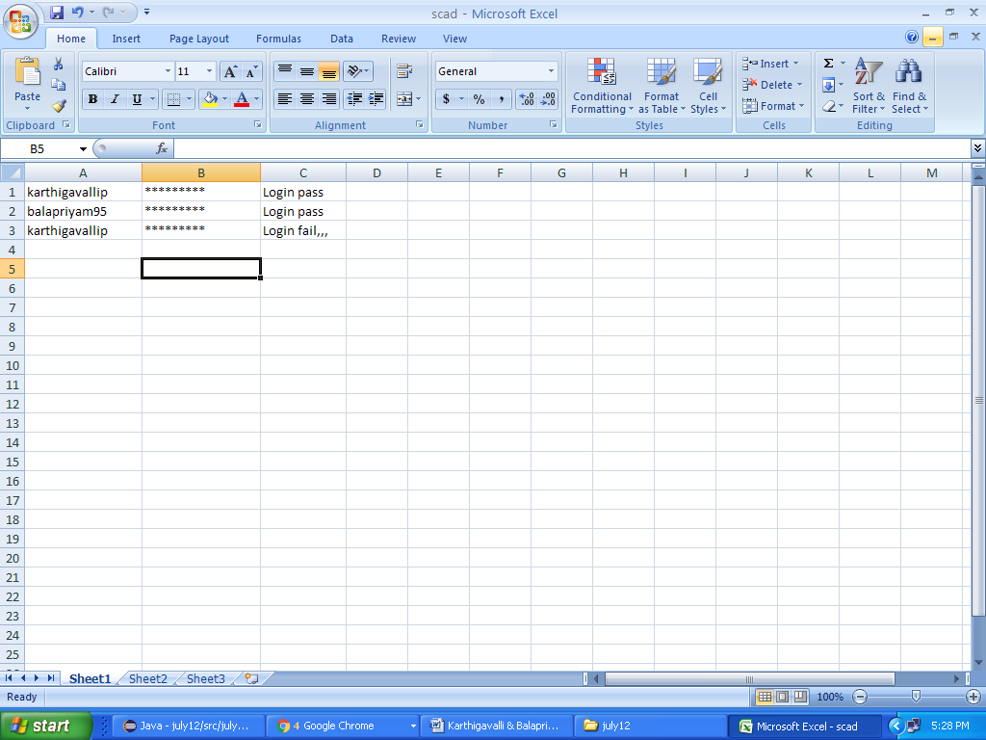

**TO SHOW THE STATUS OF LOGIN AND LOGOUT USING TESTNG:**

**CODE:**

**package** july12;

**import** java.io.File;

**import** java.io.FileInputStream;

**import** java.io.FileOutputStream;

**import** java.io.IOException;

**import** java.util.concurrent.TimeUnit;

**import** org.apache.poi.ss.usermodel.Cell;

**import** org.apache.poi.xssf.usermodel.XSSFSheet;

**import** org.apache.poi.xssf.usermodel.XSSFWorkbook;

**import** org.openqa.selenium.By;

**import** org.openqa.selenium.WebElement;

**import** org.openqa.selenium.chrome.ChromeDriver;

**import** org.testng.annotations.BeforeTest;

**import** org.testng.annotations.Test;

**public** **class** NewTest {

@BeforeTest

**public** **void** f()

{

System.*setProperty*("webdriver.chrome.driver","C:\\Program Files\\Java\\jdk1.8.0_131\\chromedriver.exe");

ChromeDriver driver = **new** ChromeDriver();

}

@Test

**public** **static** **void** login() **throws** IOException, Exception{

ChromeDriver driver = **new** ChromeDriver();

FileInputStream f1= **new** FileInputStream(**new** File("D:\\workspace\\july12\\scad1.xlsx"));

XSSFWorkbook w = **new** XSSFWorkbook(f1);

XSSFSheet worksheet = w.getSheetAt(0);

Cell cell ;

**for** (**int** i = 0; i<=3;i++) {

driver.get("https://accounts.google.com/signin/v2/identifier?continue=https%3A%2F%2Fmail.google.com%2Fmail%2F&service=mail&sacu=1&rip=1&flowName=GlifWebSignIn&flowEntry=ServiceLogin");

driver.findElement(By.*xpath*("//.//*[@id='identifierId']")).sendKeys(worksheet.getRow(i).getCell(0).getStringCellValue());

driver.findElement(By.*cssSelector*("span.RveJvd.snByac")).click();

Thread.*sleep*(10000);

driver.findElement(By.*xpath*("//.//*[@id='password']/div[1]/div/div[1]/input")).sendKeys(worksheet.getRow(i).getCell(1).getStringCellValue()); driver.manage().timeouts().implicitlyWait(5, TimeUnit.***SECONDS***);

Thread.*sleep*(1000);

driver.findElement(By.*cssSelector*(".RveJvd.snByac")).click();

Thread.*sleep*(2000

**try**{

WebElement web1 = driver.findElement(By.*xpath*("//.//*[@id='password']/div[2]/div[2]"));

**boolean** a2 = web1.isDisplayed();

**if**(a2 = **true** ){

cell = worksheet.getRow(i).getCell(2);

cell.setCellValue("Login fail,,,");

f1.close();

FileOutputStream output_file1 =**new** FileOutputStream(**new**File("D:\\workspace\\july12\\scad1.xlsx");

wb.write(output_file2);

output_file2.close();

}}

**catch** (Exception e) {

driver.findElement(By.*cssSelector*(".gb_8a.gbii")).click();

driver.findElement(By.*cssSelector*("#gb_71")).click();

cell = worksheet.getRow(i).getCell(2);

cell.setCellValue("Login pass");

f1.close();

FileOutputStream output_file2 =**new** FileOutputStream(**new** File("D:\\workspace\\july12\\scad1.xlsx"));

w.write(output_file2);

output_file2.close();

Thread.*sleep*(1000);

}

}

driver.quit();

}

}

**Output:**

